

WEB PROGRAMING PROJECT REPORT

**JM SCHOOL (Elearning website)**

***Submitted By***

*Zohra Sardar*

(20-P-0754)

Wajiha Mehboob

(20P-00476)

***Submitted to***

MR. Musadiq Mansoor

## DEPARTMENT OF COMPUTER SCIENCE FAST NATIONAL UNIVERSITY OF COMPUTER AND

**EMERGING SCINCES, PESHAWAR**

**Session 2019-2023**

**OBJECTIVE:**

The main objective of our e-learning website

is to enhance the learning process. Our website not only delivers content, but also handles registering courses, course administration, skill gap analysis, tracking, and reporting.

**FLOW CHART DIAGRAME OF PROJECT:**

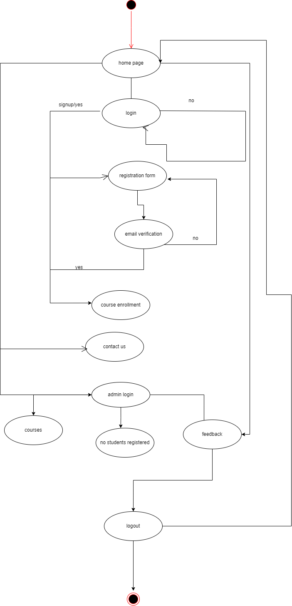

**ABOUT THE PROECT:**

This project is about school e-learning website. Our website includes online learning system. It’s divided into two panels which include students and admin panel. When you visits our website we have a student panel in which student see our website information which include login functionality, registration form, feedback , courses and contact us form.

Contact us form is for every one and make a query and contact with us related to our website. No one can have a access to our course without login and registration form.

With login you have access for the enrollment of our website courses. After enrollment you can see our course details and videos. In future we can explore and add more courses

The second is admin panel. Administration panel is fixed. Administration panel can see student enrollment , courses for further future updation , addition ,deletion and feedback(delete). Basically our website eLearning has completely transformed the way in which learning is imparted to students. Unlike traditional chalk and board method of teaching, our website makes learning

simpler, easier, and more effective

# PROJECT INCLUDES FOLLOWING FUNCTIONALITY:

1. Home page
2. Login page
3. Signup
4. Admin
5. Courses
6. Payment
7. Feedback(5 star system)

**HOME PAGE:**



Home page consist of following sections

* + Header
  + Video display
  + Banners
  + Static courses cards(as its only frontend)
  + Contact us form
  + 5 star rating(only fontend)
  + About us section
  + Footer

**HEADER**

Header includes our website information,by clicking on that one can check our popular courses,login registration form,give us feedback,contact for any query,see their profile.

**HOME PAGE VIDEO DISPLAY:**

This the home page of our project “WELCOME TO JM SCHOOL”.

**BANNERS:**



**COURSES:**

By login and registered successfully one can enroll his or her self in our courses mentioned in our website

**Contact us form:**

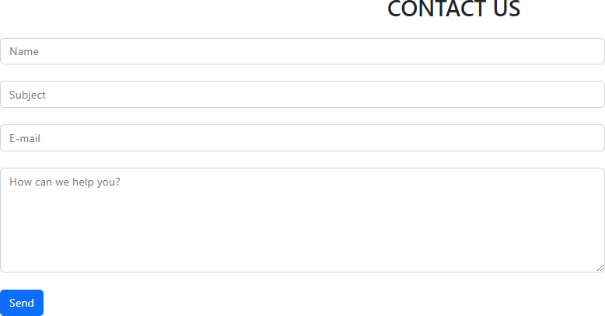

This contact form is for every one.Any one can contact us without login and make a query with us.

**5 STAR RATING:**



Its is just frontend only.You can tell us our experiences by rating our website.

**ABOUT US SECTION**

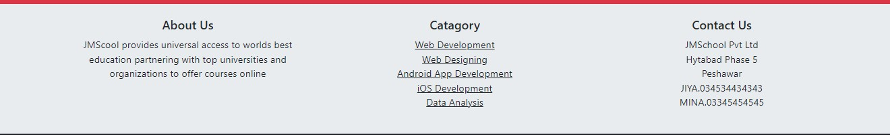

In our about us section you can see and ask any query regarding our courses category or any other info.

**FOOTER**

We can go to admin page by clicking on admin in footer



**LOGIN PAGE**

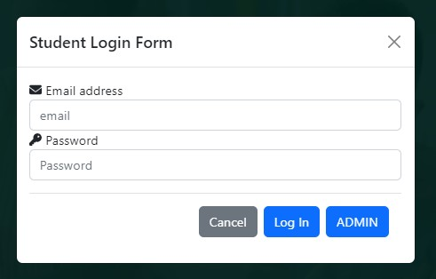

By visiting our website,he/she must login in to our website for enrollment in any courses.

**SIGNUP PAGE**

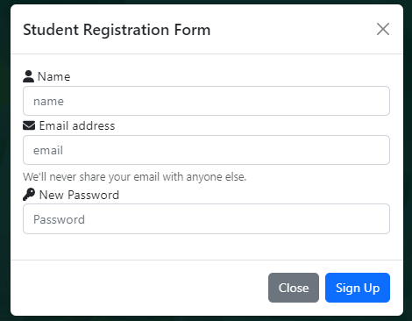

This is our signup page for the “student registration form”.

By the registeration of email verification once can visit our whole website info and see any courses category.

**ADMIN**

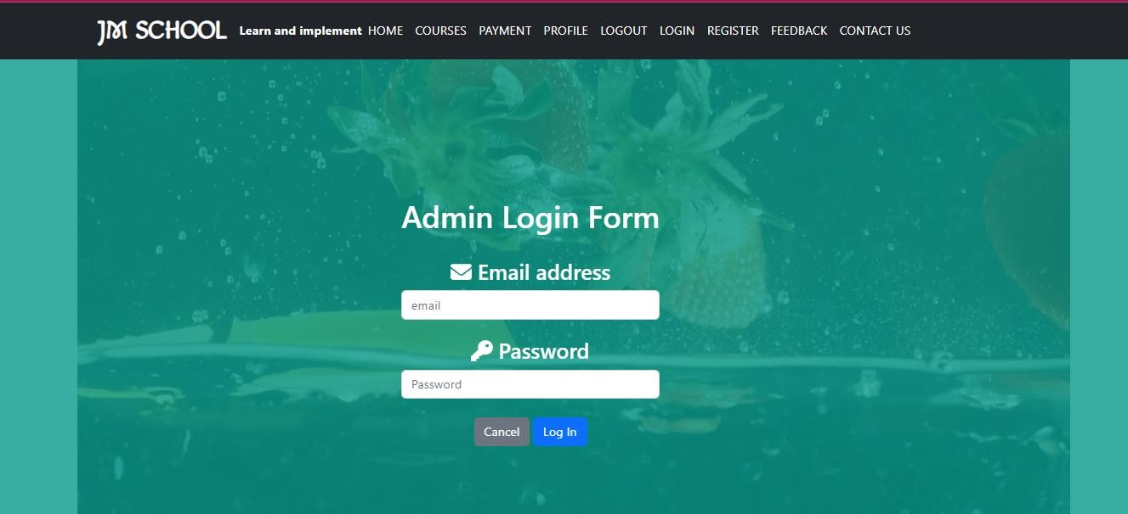

If any body make a contact to admin,by this “admin login form”

You can contact us for any detail.

**COURSES**





In our courses,we offer the most popular courses, their videos and lectures online.For the enrollment once must have login and registered his/herself.

**FEEDBACK**



Feedback page tell your experience by rating the website

**EMAIL VARIFICATION USING JAVASCRIPT:**

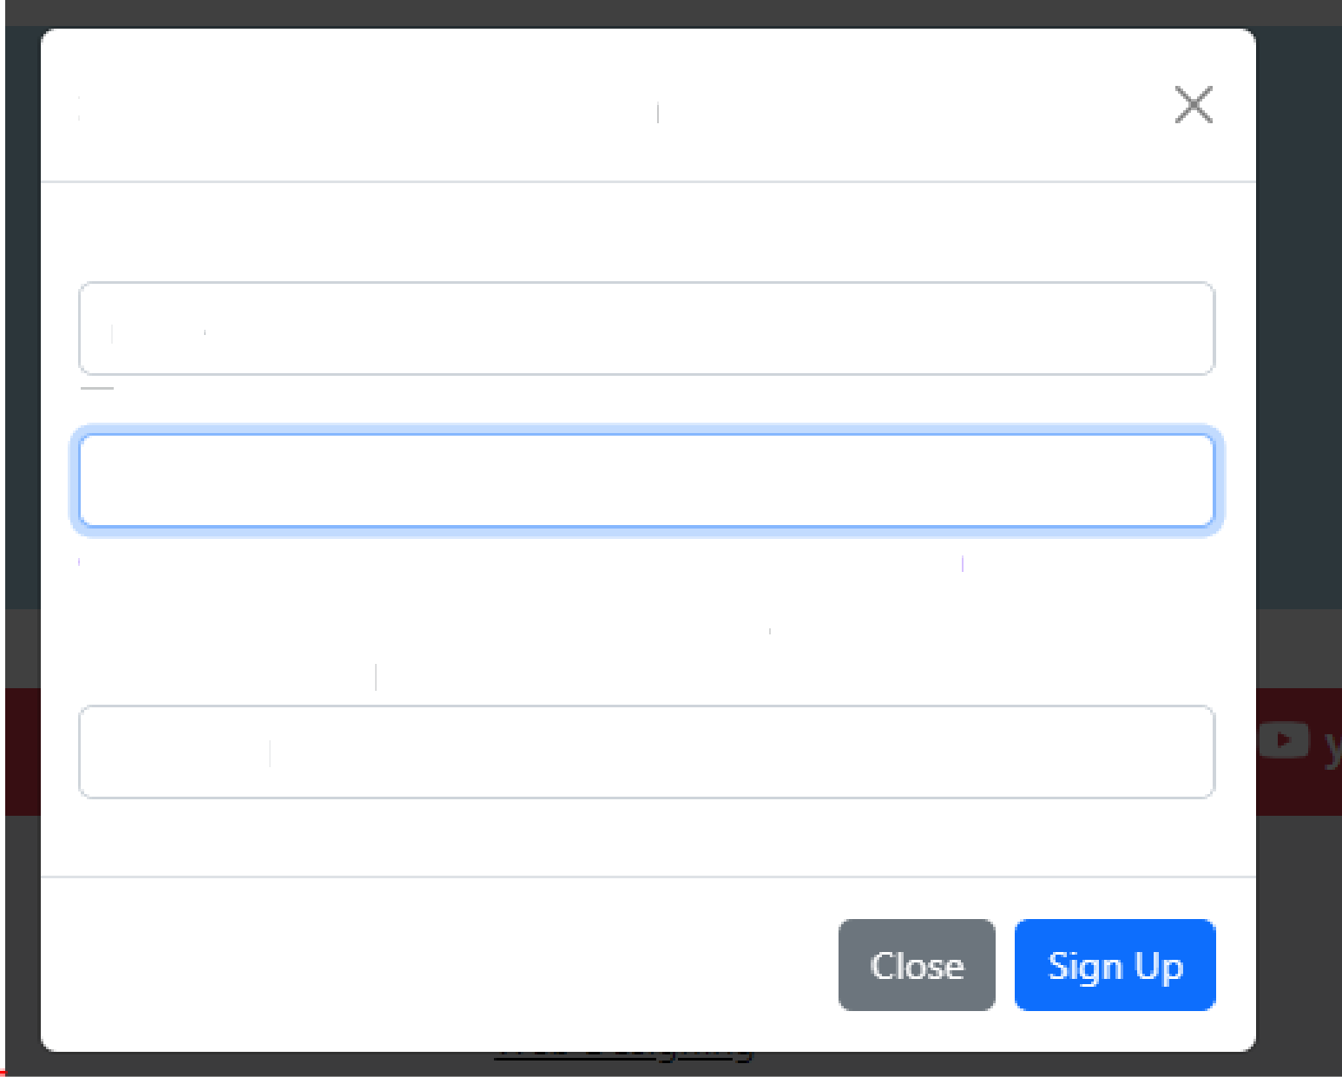

Student Registration Form

Name name

W Email address DSSDS)

email should be in a formate of example Bmail.com

We'll never share your email with anyone else.

New Password

Password

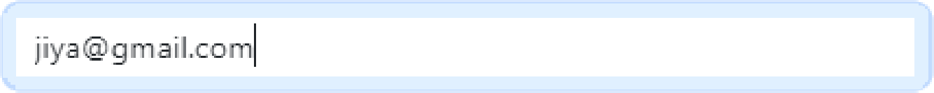

Student Registration Form

X

Name

name

@ Email address

valid email.thanks

We'll never share your email with anyone else.

New Password

)t Password

This is our email verification page using java script by typing correct email format. By incorrect format it will show you the error.

**Code is attached in .rar file**